INSTRUCTION SETS
Machine code
Its a set of instructions

RISC – Reduced instruction set
Risc – smaller commands finished with a single cycle
Risc is generally less efficient
CISC – complex instruction set
CISC – minimizes number of instructions
Windows was built in with CISC in mind – hurting RISC
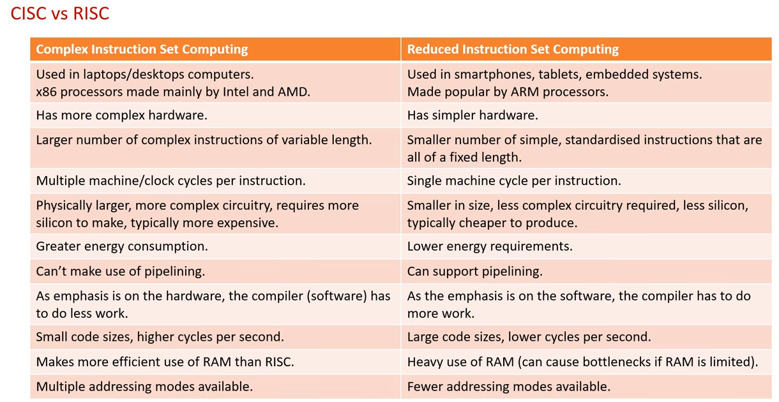

LDA = LOAD
STA = STORE
R1 = REGISTER 1

CPUs excel on small data sets
GPUs better on larger data sets

GPUs excel on maps/ matrices
Can multitask

Amdahl’s law – how much will the number of cores increase the speed of the cpu
More cores doesn’t always mean faster speed
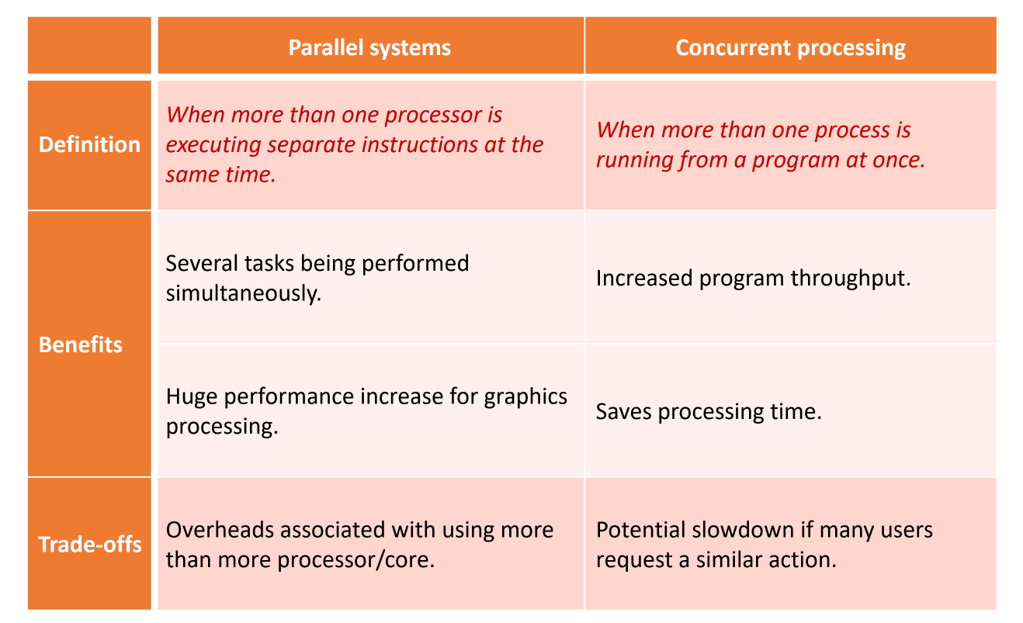

2026
CPUs best used on small complex tasks
GPUs best used on large simple tasks.

